Programming New Bridges
  - Last Update: March 2nd, 2023
Contents
1. Prerequisites 1
2. STM32CubeProgrammer Configuration 1
3. Procedure 3
Set Bridge Switch to Bootloader Position 3
Connect USB to Bridge 3
Refresh the DFU Port and Connect 4
Start Programming 4
Switch Bridge Switch to Run Position 5
Connect to Tester and Start Test Like Usual 5

Prerequisites
The STM32CubeProgrammer software is required. If it is not already installed it can be downloaded here: https://www.st.com/en/development-tools/stm32cubeprog.html
A hardware tester with hardware version 2.2 or greater is also required.

STM32CubeProgrammer Configuration
Open the STM32CubeProgrammer and go to the Erasing and Programming page:
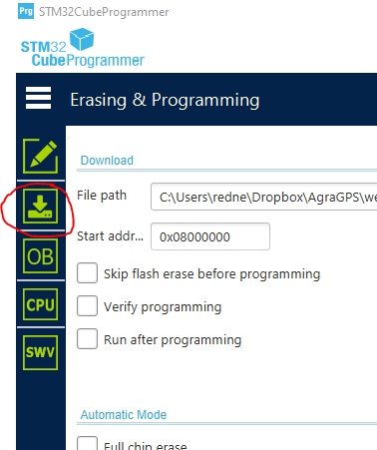
In file path, select the latest firmware (Or testing firmware when doing hardware testing) for the bridge being updated from the Dropbox. (BRIDGE-SHELL.bin, not BRIDGE-SHELL_update.bin)
Set everything else. Items circled in red must be set as shown:
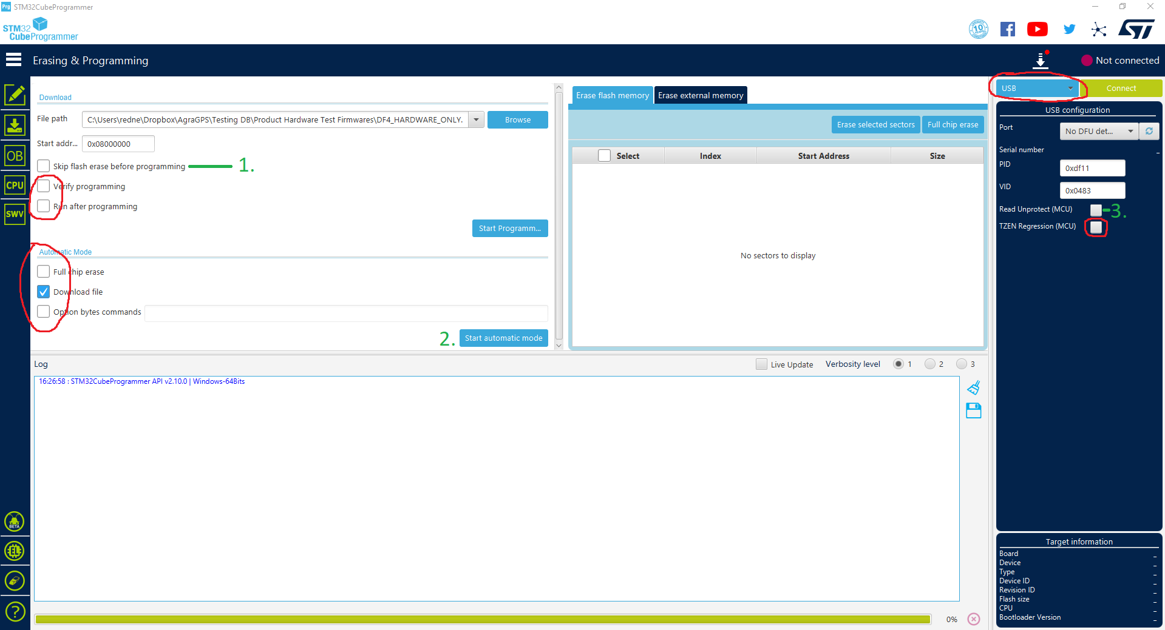
Programmer/Bridge Configuration | 1. Skip flash erase before programming | 2. Can use automatic mode | 3. Read Unprotect
Newly manufactured bridge | Can check to speed up programming | Yes | Does not matter
New bridge, has only been hardware tested | Must be unchecked | Yes | Does not matter
Bridge that has had a release firmware programmed before | Must be unchecked | No | Must be checked

Procedure

Set Bridge Switch to Bootloader Position
Newly manufactured bridges come in this position by default.
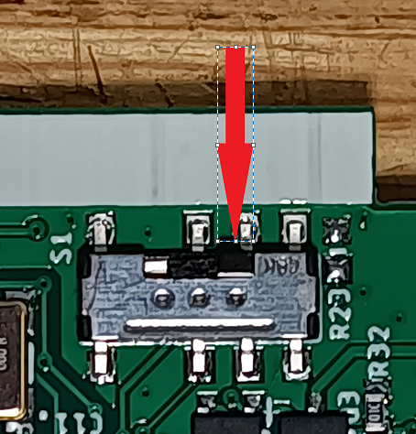

Connect USB to Bridge
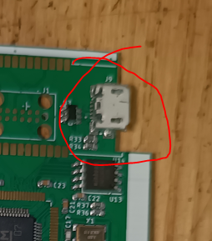

Refresh the DFU Port and Connect
This is not necessary (or possible) if automatic mode has been started. It will automatically start programming once the bridge USB has been connected.
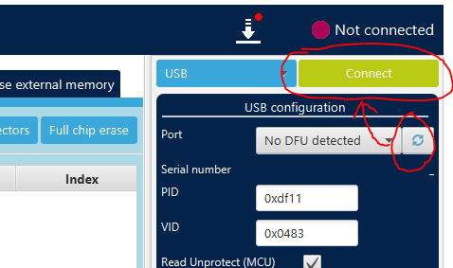
If it has been programmed with a release version of the software before, the MCU will be locked. It will now unlock the MCU. Wait until this is complete:
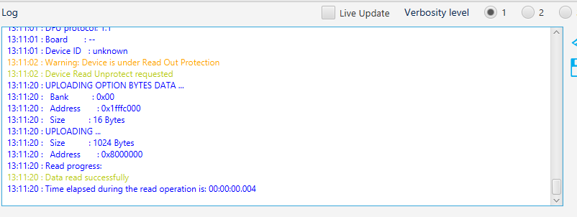

Start Programming
This is not necessary (or possible) if automatic mode has been started.
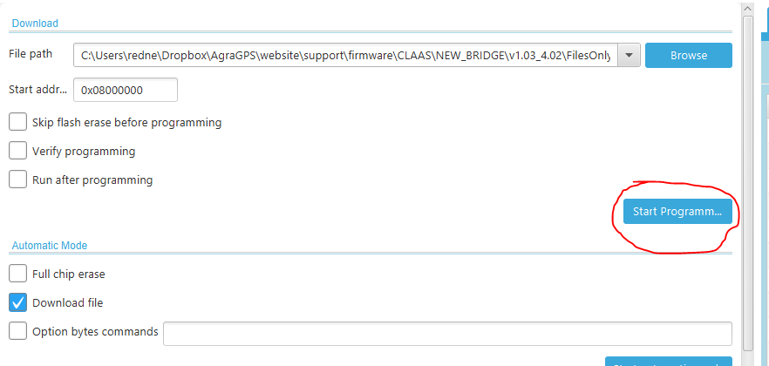
Wait until complete

Switch Bridge Switch to Run Position

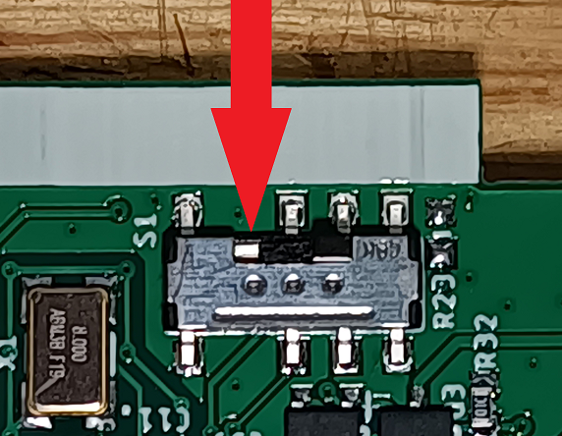
Do not remove the USB until test is complete

Connect to Tester and Start Test Like Usual
Keep the USB plugged in, the tester will need to use it to transfer files to the Bridge

